**Summit Station Weekly Science Report**

**Reporting Period:**  January 28– February 3, 2019

**Completed by:** Gus Allen, Troy Nave

**Comments:** Techs have been preparing for turnover with the spring crew, who are scheduled to arrive on Thursday. A G1 geomagnetic storm occurred on February 1, which sparked significant auroral activity.

Wind speeds at Summit ranged from 0.0 m/s, recorded on 2019-02-03, to 10.8 m/s on 2019-01-31. The average wind speed for the week was 5.8 m/s. Temperatures ranged from a low of -53.09˚C on 2019-02-02 to a high of -28.10˚C on 2019-01-28. The average temperature was -43.67˚C.

Summit experienced low winds intermittently from 1905 to 1227 Z on 2019-01-30, intermittently from 0035 to 0215 Z on 2019-01-31, and intermittently from 0341 to 0614 Z on 2019-02-03. North winds were frequent, occurring intermittently from 0026 to 0842 Z on 2019-01-28, intermittently from 0514 to 0809 Z on 2019-01-29, intermittently from 1913 to 2359 Z on 2019-01-30, intermittently from 0001 to 1006 Z on 2019-01-31, and intermittently from 0200 to 2359 Z on 2019-02-03 last week.

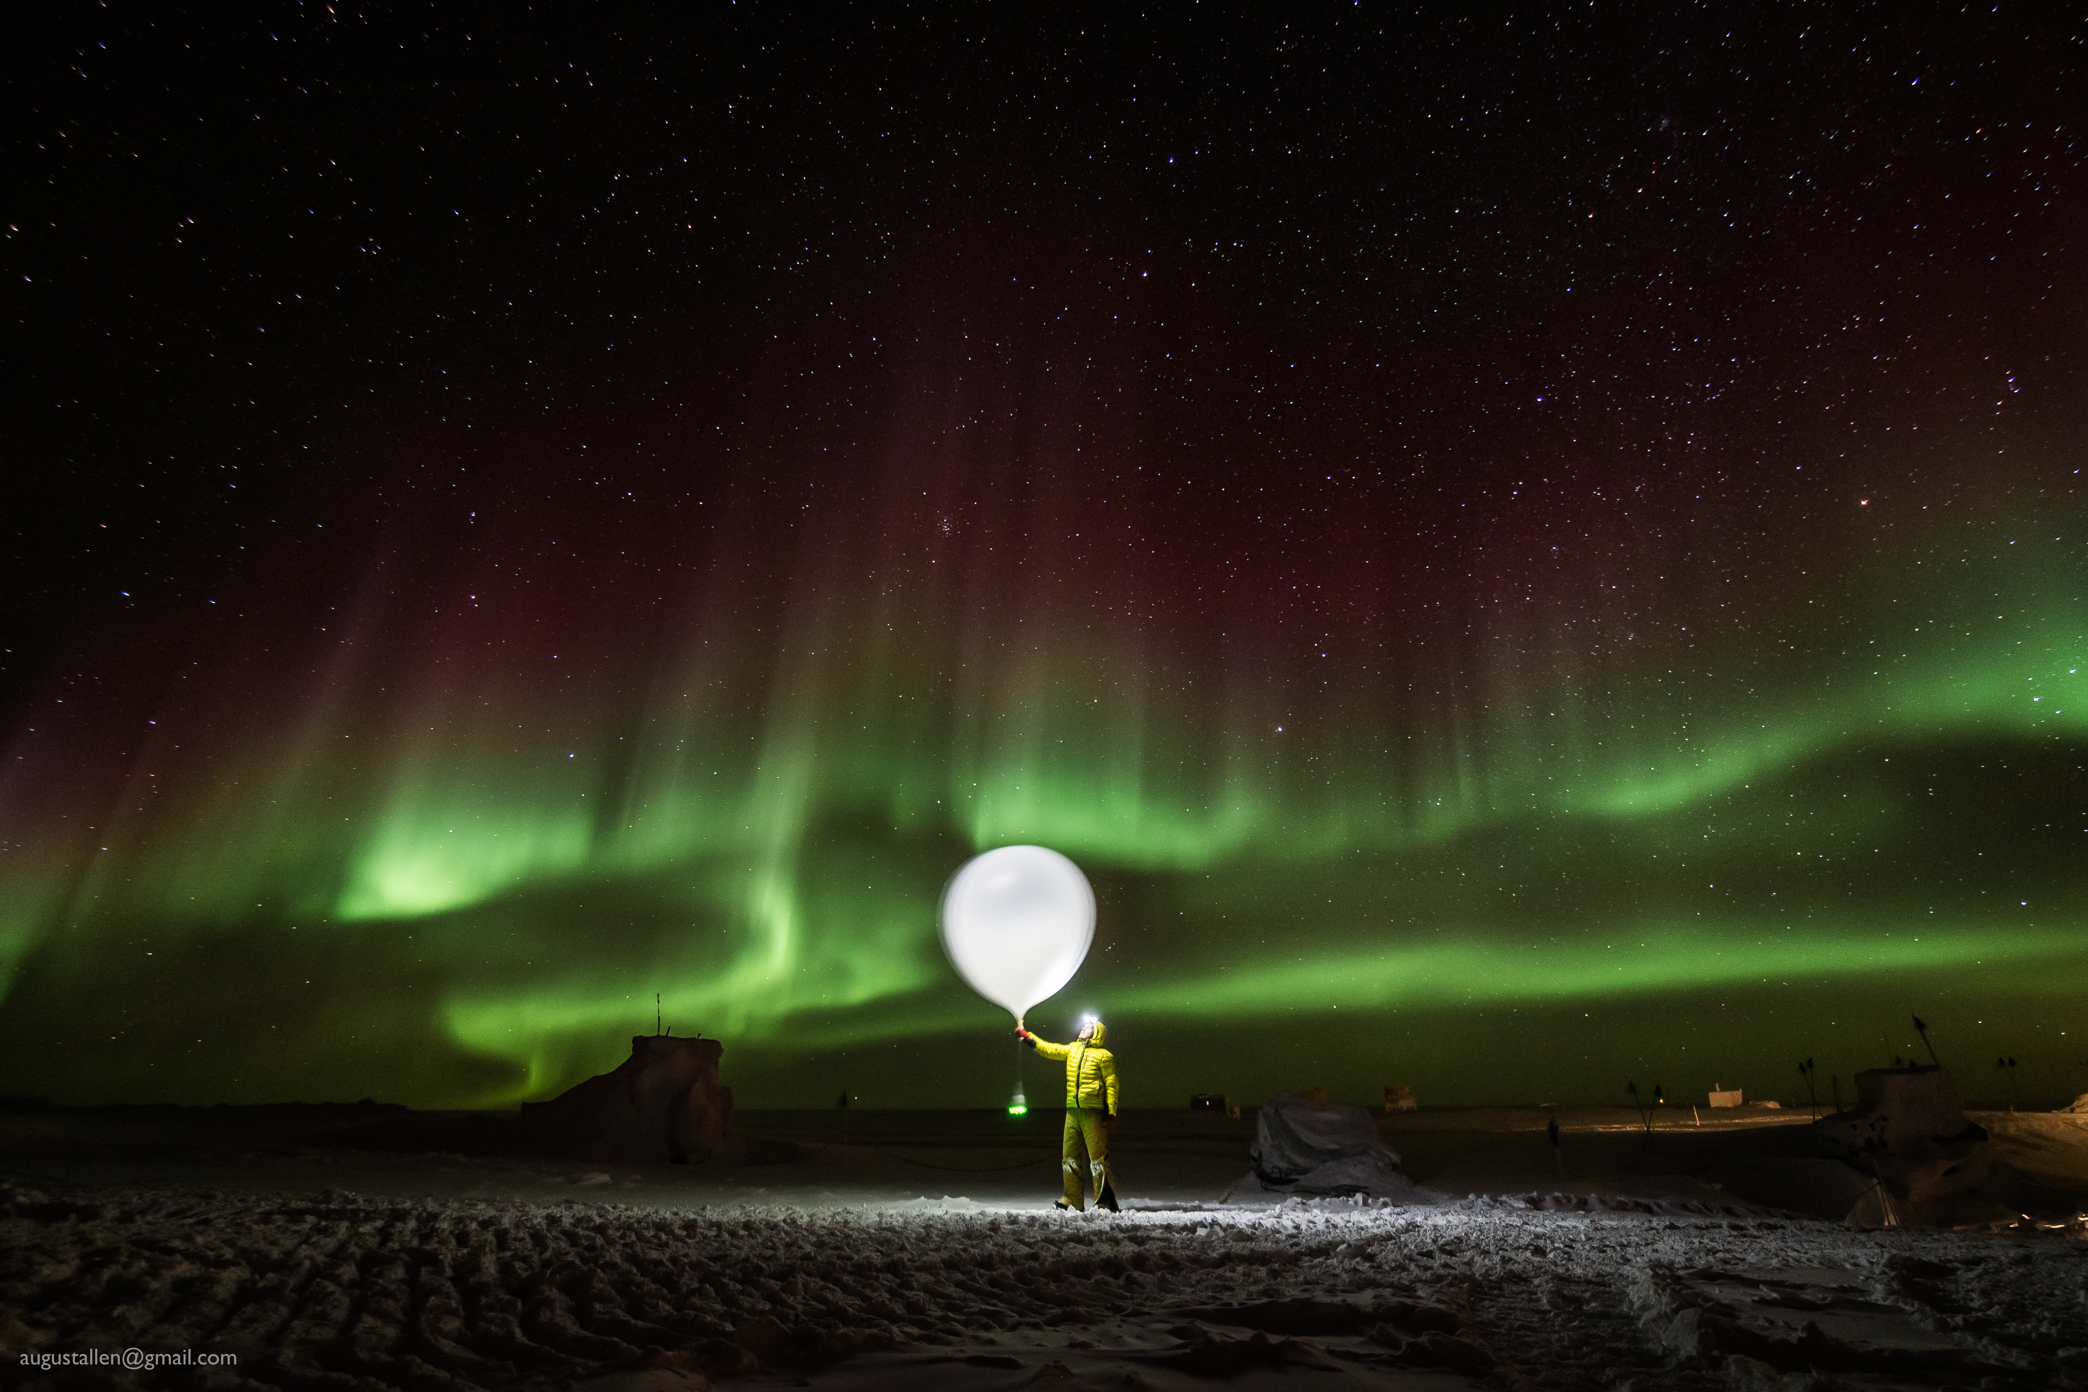

Radiosonde balloon launch during a geomagnetic storm

**Please visit the clean air log at ftp://isr.sri.com/pub/summit/ftp/science/clean_air_traffic/**

|  |  |
| --- | --- |
| **Facilities** | **Comment** |
| TAWO | H2 generator needs part; H2 being supplied by cylinder.. |
| MSF | MMCR level 0.11 pitch 0.00 roll |
| Green House | Greenhouse tower cleaned 02-02 |
| **Experiment** | **Notes** |
| NOAA CCGG flasks | Comment:  Date performed: 2019-1-31 |
| NOAA HATS flasks | Comment: twice per month  Date performed: 2019-1-24 |
| NOAA Surface Ozone | Comment: Calibrated on 2019-1-29.  % of time operating: 100% |
| NOAA Aethelometer | Comment: Instrument offsite for service.  % of time operating: 0% |
| NOAA Meteorology | Comment:  % of time operating: 100% |
| NOAA CLAP & Neph | Comment: Span check occurred on 2019-01-29  % of time operating: 100% |
| Radionuclide Filter | Comment: Changed every other day  % of time operating: 100% |
| Aerosol DRUM Sampler | Comment:  % of time operating: 100% |
| Bamboo Forest | Comment:  Date performed: 2019-1-26 |
| SnowFox | Comment:  Date performed: 2019-1-30 |
| ICESat Accumulation | Comment:  Date performed: 2019-1-16 |
| GFZ Potsdam Seismometer | Comment:  % of time operating: 100% |
| DTU Magnetometer | Comment:  % of time operating: 100% |
| UNAVCO | Comment: |
| Helmig CUGC | Comment: Using cylinders for H2 supply.  % of time operating: 100% |
| Steffen Tower Instruments | Comment:  % of time operating: 100% |
| Steffen Solar Instruments | Comment:  % of time operating: 100% |
| ICECAPS-ACE Total Sky Imager | Comment: Offline for the winter.  % of time operating: 0% |
| ICECAPS-ACE Radiosonde | Comment:  Dates performed: Twice daily. |
| ICECAPS-ACE MWR | Comment:  % of time operating: 100% |
| ICECAPS-ACE SODAR | Comment:  % of time operating: 100% |
| ICECAPS-ACE POSS | Comment: Instrument taken offline briefly on 02-03 to allow its stand to be dug up and raised to snow surface.  % of time operating: 98% |
| ICECAPS-ACE MASC | Comment: Instrument offsite for service; expected return 2019-06.  % of time operating: 0% |
| ICECAPS-ACE MMCR | Comment:  % of time operating: 100% |
| ICECAPS-ACE CAPABL | Comment: Data collection stopped for ~2 hours for laser alignment on 02-01  % of time operating: 99% |
| ICECAPS-ACE MPL | Comment:  % of time operating: 100% |
| ICECAPS-ACE Ceilometer | Comment:  % of time operating: 100% |
| ICECAPS-ACE PAERI | Comment:  % of time operating: 100% |
| ICECAPS-ACE IcePIC | Comment: No images captured this week  Date(s) performed: |
| ICECAPS-ACE CLASP | Comment: Instrument offsite for service; expected return 2019-02.  % of time operating: 0% |
| ICECAPS-ACE CPC | Comment: Instrument offsite for service; expected return 2019-02.  % of time operating: 0% |
| ICECAPS-ACE OPC | Comment: Instrument is operational and collecting data, but files are not presently being transferred via DATAMAN.  % of time operating: 100% |
|  |  |  |
|  |  |  |